Air Pollution in the United Kingdom

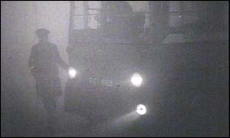
Do you need air to breathe in order to stay alive? But how clean is the air you breathe? If you breathe polluted air, you are more likely to develop health problems and become ill. Plants and animals need clean air too. A lot of the things that make our lives more comfortable such as cars, electricity and heating create harmful gases which make the air polluted. The problem of air pollution started with the burning of coal in homes and factories, as well as the Industrial Revolution.
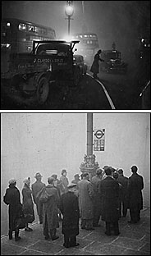
BLAST FROM THE PAST
About 500 years ago in Great Britain, the burning of coal was increasing in cities like London. Coal was used in factories and also used to heat homes. Coal, when burnt makes a lot of smoke, which makes the air very dirty. About 200 years ago, the Industrial Revolution began in Britain. Factories were built, and even more coal was burnt because it was a cheap and abundant natural resource. Air pollution was becoming a really big problem, especially when the weather was foggy. With foggy conditions and light winds the smoke or air pollution covered the whole city, and would linger for hours and even days.
Smog is air pollution caused by sunlight acting on the gases from factory exhausts and automobiles. When smog was stuck over a city, it became really hard to breathe and see clearly. In 1952, the Great London Smog occurred and more than 4,000 people died because of the smog! People could not see in front of them, transportation came to a standstill, and crime increased. However, factories were not the only cause to the Great London Smog, exhaust from gasoline and diesel fuel were also to blame.
New laws were created from this catastrophe in 1956 and 1968, so that it would not happen again. The Government could not ignore the Great London Smog and so the first Clean Air Act was eventually introduced in 1956 and again in 1968. The Act in 1968 aimed to control domestic sources of smoke pollution by introducing smokeless zones. In these areas, smokeless fuels had to be burnt. The Clean Air Act focused on reducing smoke pollution but the measures taken actually helped to reduce sulphur dioxide levels at the same time. Air pollution in cities dramatically reduced in the following ways.

- domestic emissions reduced because of smoke control areas
- electric and gas usage increased and the use of solid fuels decreased
- cleaner coals were burnt which had a lower sulphur content
- use of tall chimney stacks on power stations
- relocation of power stations to more rural areas
- Continued decline in heavy industry.

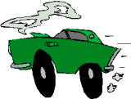
WHAT IS TODAY'S AIR POLLUTION LIKE?
Have you ever noticed that the air in a city smells different from air in the country? One of the reasons is that exhausts from vehicles give off fumes, or gases, which can poison you. Today, when we think of air pollution, we should think of transportation pollution, like cars. Today there are about 23 million vehicles on the road in Great Britain, and 20 million of them are cars! The fuel they use - petrol and diesel fuel - releases a lot of pollution in the air.
The car exhausts eject a lot of bad gases, which create air pollution. These gases can be very dangerous for children. Although the fuels are becoming cleaner, it will not be making that much difference because there are more and more cars. There is less pollution from coal, but today's modern world still creates air pollution. Today, air pollution has not really fallen, because new bad gases are released in the air, and there are a lot of them.
Transportation is not the only reason why we have air pollution. Factories also release bad gases in the air, even with the 'Clean Air Acts,' it still causes a lot of air pollution. This air pollution that they make is the main cause of acid rain.
WHAT ARE THESE BAD GASES?
Gases from vehicles:
- Carbon monoxide - Carbon monoxide is a gas that pollutes the air, and is mainly released by cars and other vehicles. It has no color or smell.
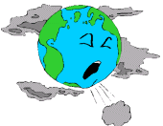
- Nitrogen oxides - Nitrogen oxides are emitted from vehicles, like cars and trucks. During rush hour periods, a lot more is released in the air. Nitrogen oxides are also emitted from power stations. These gases also make acid rain.
- Hydrocarbons - Hydrocarbons are produced when petrol is not fully burnt. They are one of the causes of modern-day smog.
- Particulates - Particulates are very small particles, like soot, dust and fumes that are released in the air. They are caused by vehicles, factories and smoke from homes burning coal for heating.
Gases from factories:
- Nitrogen Oxides (see above)
- Sulphur dioxide- Sulphur dioxide has no color. Most of it is released by power stations. It causes acid rain when mixing with water in the air.

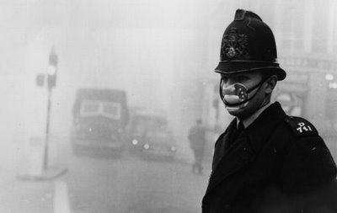
Effects of Air Pollution
Air Pollution not only harms the environment but it also harms our health too. Air pollution burns the nose, lungs, eyes, and endangers human life. Medical problems such as asthma and pneumonia are also linked to air pollution. Cleaner coals, increased use of electricity and use of gas have helped reduce air pollution. “Smokeless zones” were created in the United Kingdom after the Great London Smog. In these areas, only smokeless fuels could be used. Air quality is checked by the government on a regular basis. Air quality has improved greatly, however the United Kingdom still ranks in the top ten in the world in harmful industrial emissions.

