Great Lakes Resources
Websites:
- http://www.ec.gc.ca/grandslacs-greatlakes/default.asp?lang=En&n=BB02C773-1
- http://glc.org/
Articles:
- http://www.epa.gov/oaqps001/gr8water/xbrochure/lakes.html
- http://www.ec.gc.ca/doc/eau-water/grandslacs-greatlakes_e.htm
- http://environmentaldefence.ca/issues/safeguarding-canadas-water/protecting-great-lakes
- Coach book- pg 50 ( see below)
- http://www.nytimes.com/2013/12/15/us/scientists-turn-their-gaze-toward-tiny-threats-to-great-lakes.html?_r=0&adxnnl=1&pagewanted=print&adxnnlx=1389731003-r6Pk8t7+YwOgPsMCf6yvpg
- http://www.usc.edu/org/cosee-west/Mar212011/Great_lakes_habs.pdf

Multimedia:
- http://michiganradio.org/post/warmer-waters-fuel-toxic-algal-blooms-great-lakes
- http://www.miseagrant.umich.edu/files/2012/05/Harmful-Algal-Bloom-illustration-1000w.jpg
- http://www.miseagrant.umich.edu/explore/coastal-communities/harmful-algal-blooms-in-the-great-lakes/

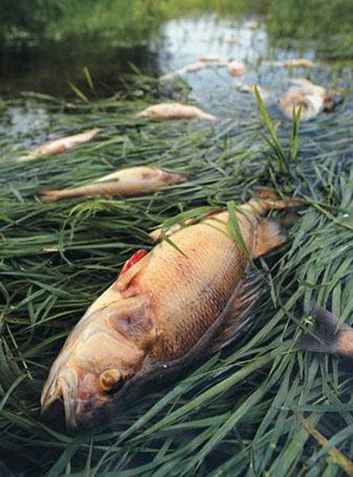
Pollution of the Great Lakes:
Industries and people in Canada depend upon the water from the Great Lakes. They use the water to drink. They also use it in the processes of their factories. Since the Great Lakes are shared between the United States and Canada, it is important for the two countries to work together to keep the lakes’ environment clean and healthy.
By the 1970’s, the Great Lakes were becoming well known for their water pollution. In some places, fishing was unsafe. In other places, there were no fish alive!!! The factories around the Great Lakes had been using the lakes as their inexpensive dumping ground. In 1972, the governments of the two countries signed an agreement to begin reduction of phosphorus. This chemical is used in fertilizer, pesticides, toothpaste, detergents, and explosives. It is bad for lakes because, in large quantities, it can cause a rapid increase in algae called an algal bloom. One result from algal blooms is the eventual death of plant and animal life in the area of the bloom.
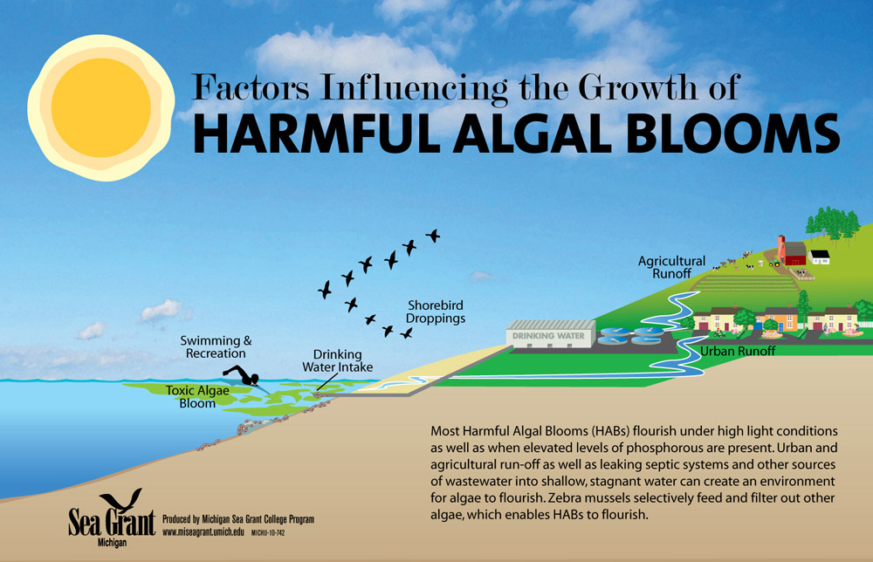
The Great Lakes Water Quality Agreement between the United States and Canada was signed in 1971 and renewed in 2002. The goal of the agreement is to restore the lakes’ environment and prevent further damage. The countries are working to make sure that chemicals that could prison animals and people are not put into the lakes. The countries are also working to reduce the amount of human wasted dumped into the lakes.
Acid Rain Questions

- How does farming contribute to pollution of the Great Lakes?

- How do industries and manufacturing contribute to the pollution of the Great Lakes?

- Why does the Canadian government have to work with the U.S. government to clean up the Great Lakes?

- Which people might be AGAINST the Great Lakes Water Quality Treatment Agreement? Why might that be? Who might be IN FAVOR (support) of the agreement? Why?

- Summarize the Environmental issue in your own words.

