Name: ______________________________________________________________ Date: ___________ Period: ________ #_______
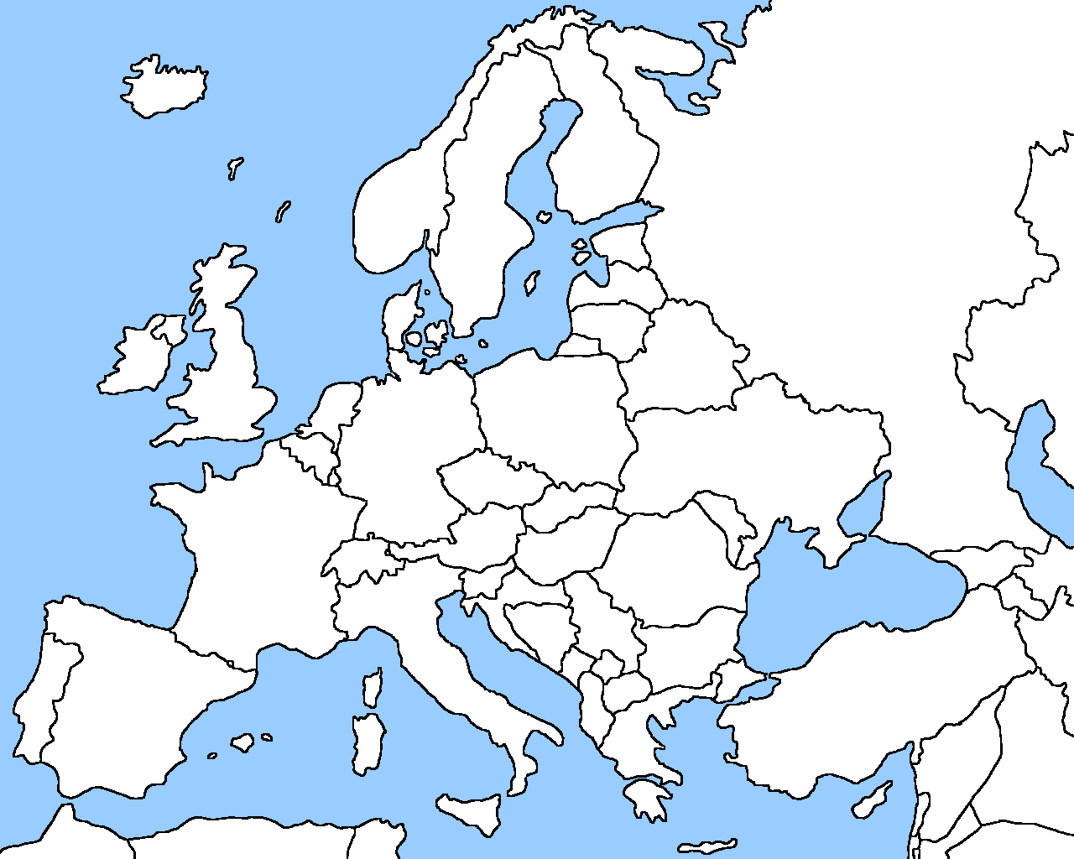
Map of Europe

