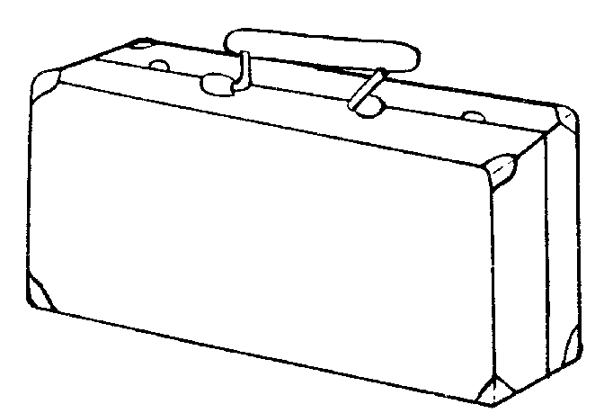

**Oh, Canada!**

**Reasons why I chose my items…**

I chose ____ because…