Term (word) | Information (definition) | Picture
province | Canadian Political Unit- (Canadian version of a State) | 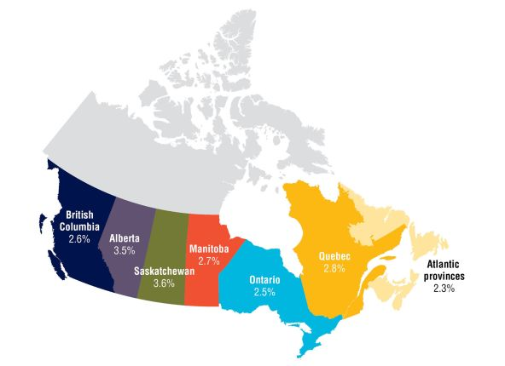
territory | -Territory is subject to Federal Government  (Provinces get to make their own laws) | 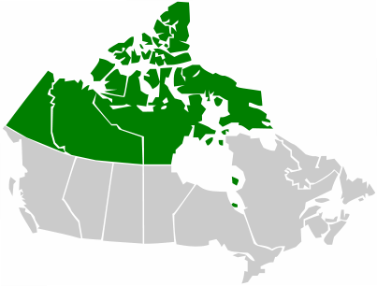
St. Lawrence Seaway | system of locks, canals and channels that permit ocean-going vessels to travel from the Atlantic Ocean to the Great Lakes,
Canadian Shield | Large Horseshoe shaped area in northern Canada, that is rich in natural resources such as mineral ores- gold, copper, iron ore. LOTS OF MINING | 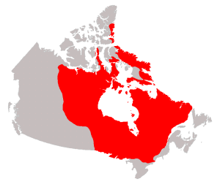
over-extraction | Taking too much out- this applies to the Canadian shield- they have mined or OVER EXTRACTED too many minerals | 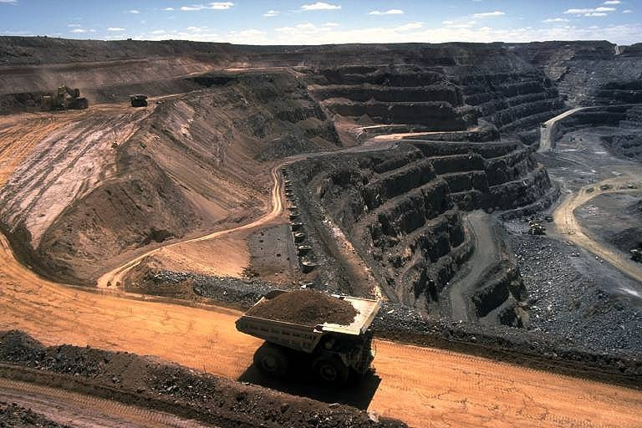
acid rain | - When chemicals from the factories join with water in the clouds, they form acid rain. (effecting Great Lakes) | 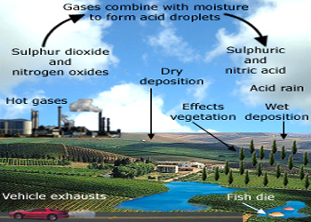
Inuit | Indigenous people of Canada | 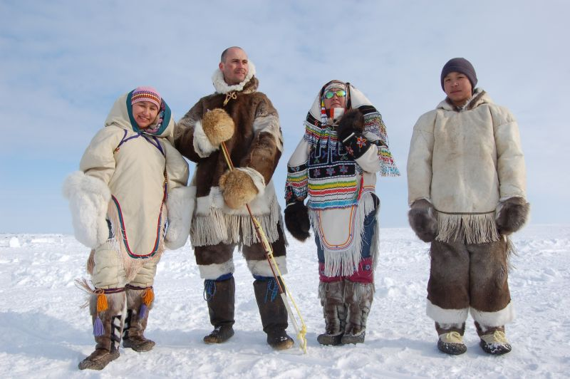
Term (word) | Information (definition) | Picture
Quebec | French colonized province. Speak French as official language | 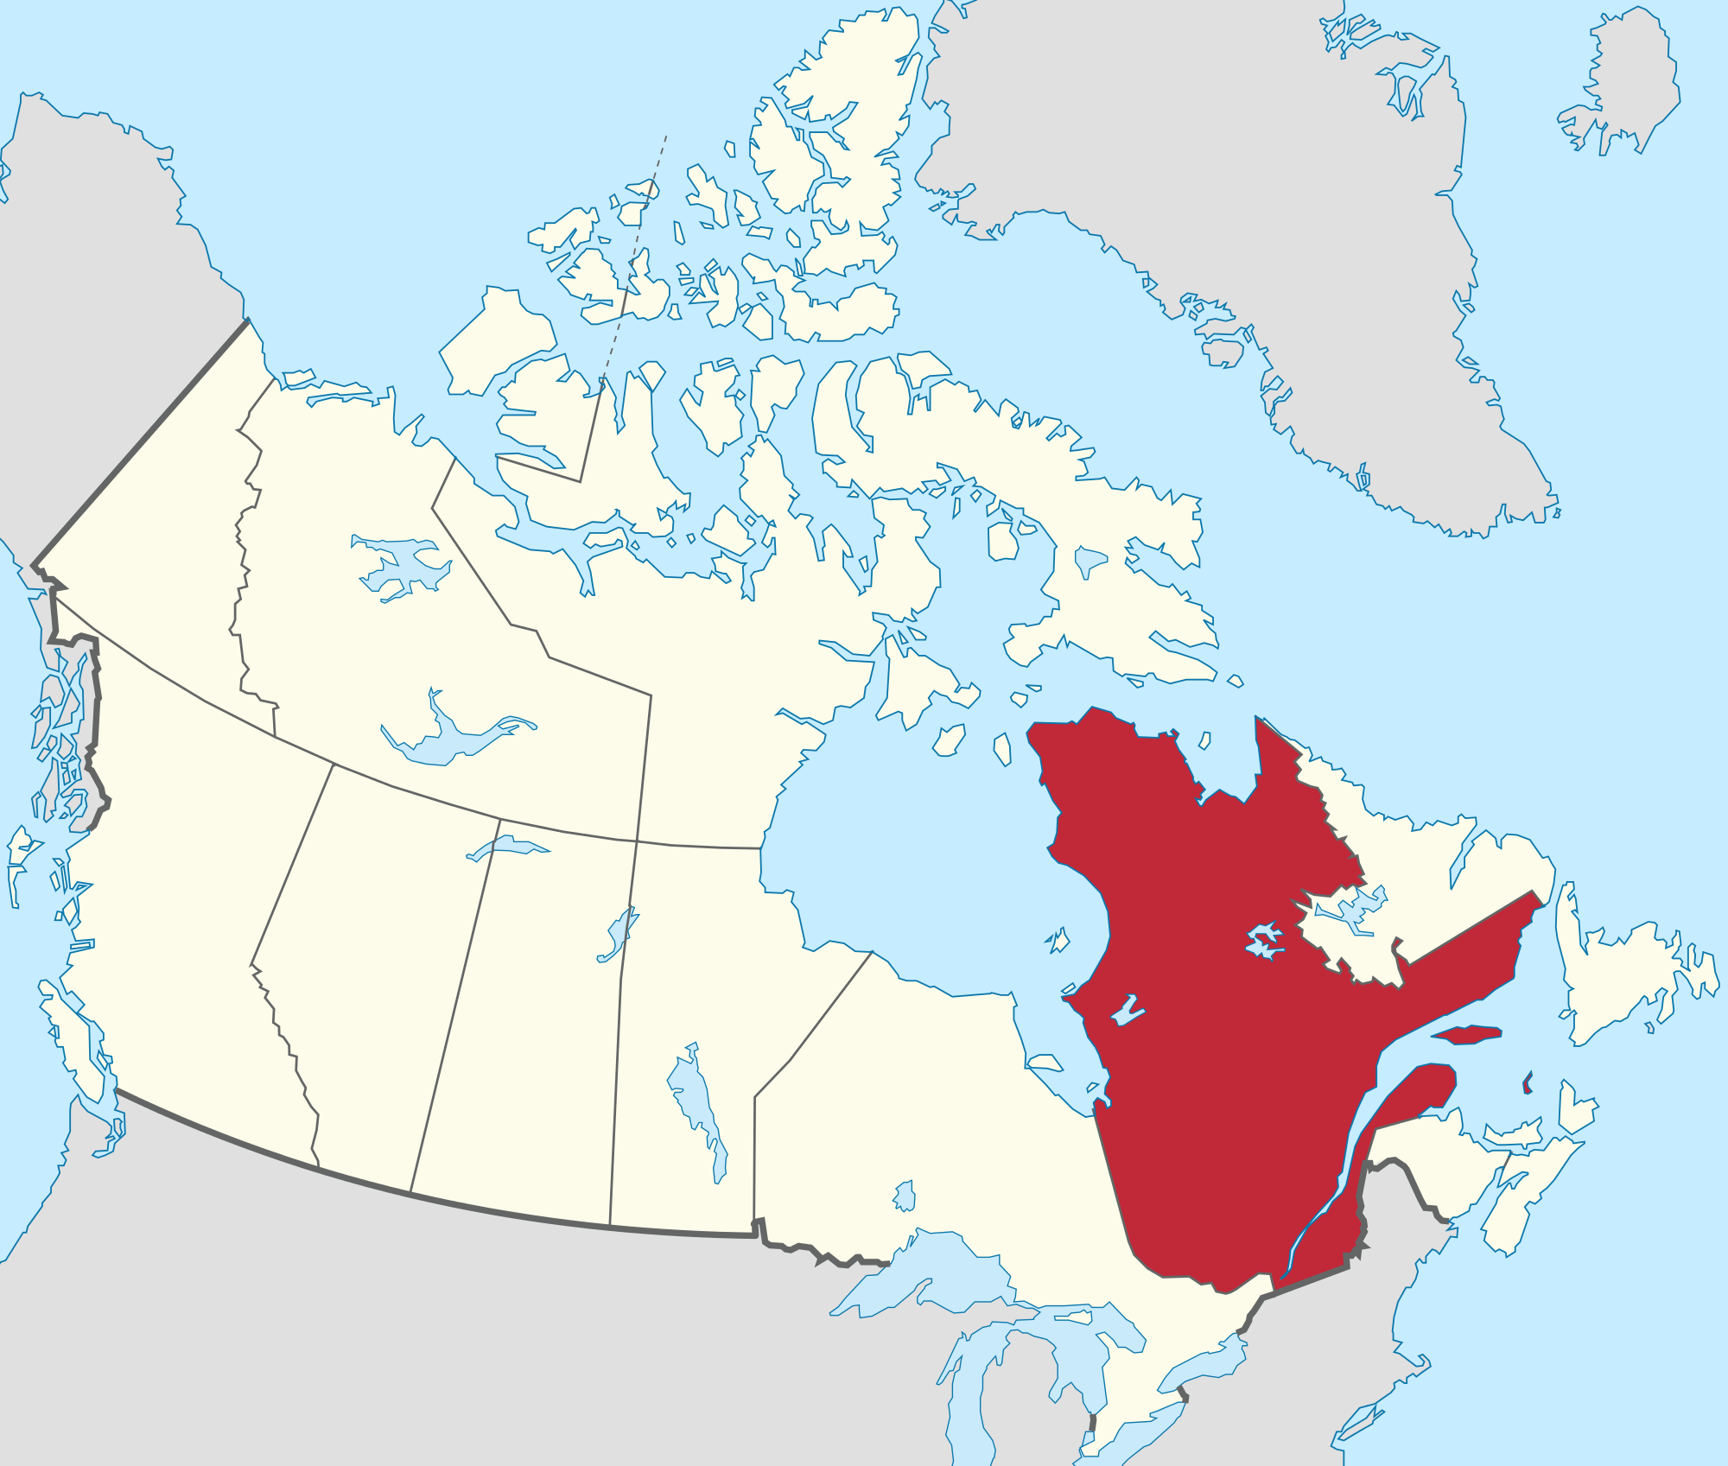
bilingual | Speaking two languages fluently | 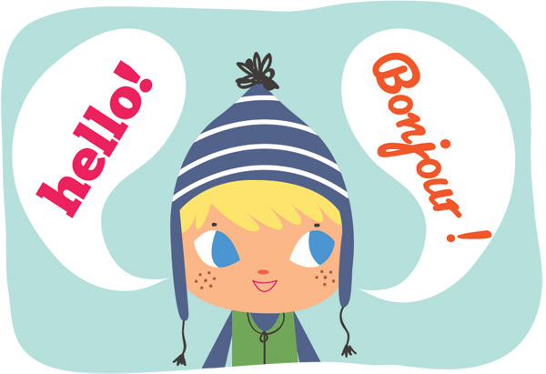
Separatist | Person who wants Quebec to break away from Canada and form their own country. | 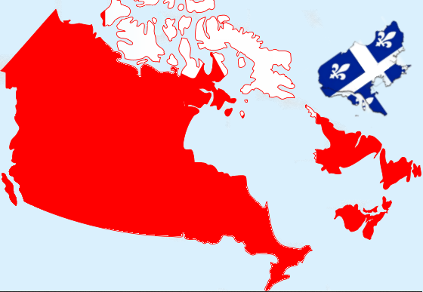
Constitutional Monarch | Monarch is limited by a constitution | 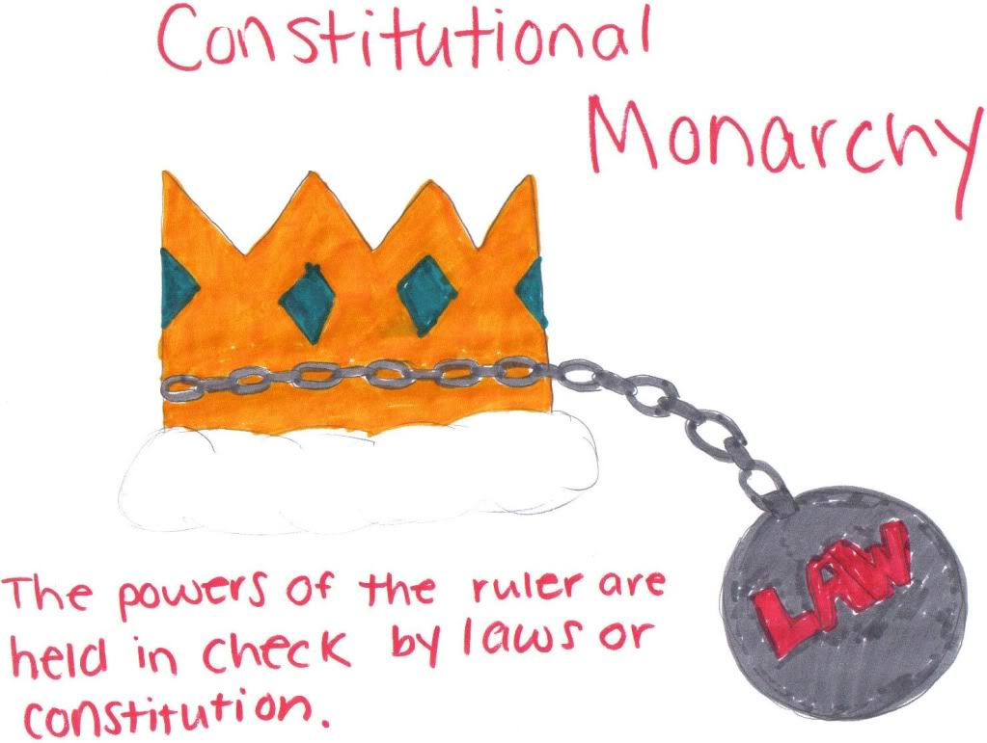
Parliamentary Democracy | Citizens elect their leaders-> leaders elect their head of government (HOG)
Federal System | Power is SHARED | 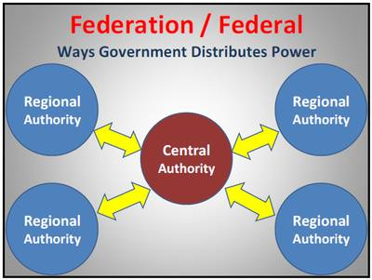
NAFTA | North American Free Trade Agreement- creates a FREE TRADE ZONE between CANADA, USA, and MEXICO | 